ArtSchoolDBExercise_FormAndBusinessRules

Form:

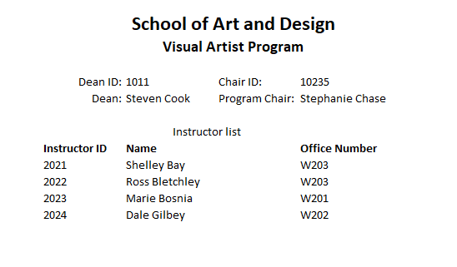

Business Rules:

* A dean can have multiple chairs assigned to him/her
* A chair can have many instructors assigned to him/her
* An instructor can only have one dean and one chair that they fall under